 **Online Bus Booking and Ticket Reserving Platform**

**TravelEASE**

**NAMES OF THE STUDENTS**

**1. KD/HDCSE/CMU/65/55 - Tharindu Wijayarathna**

**2. KD/HDCSE/CMU/65/76 - Sahanya Herath**

**3. KD/HDCSE/CMU/65/16 - Imalka Welikala**

**4. KD/HDCSE/CMU/65/48 - Piyumal Udana**

**GROUP B No 03**

**A PROJECT SUBMITTED TO**

**INTERNATIONAL COLLEGE OF BUSINESS AND TECHNOLOGY (ICBT)**

**IN PARTIAL FULFILLMENT OF THE REQUIREMENTS**

**FOR THE**

**HD in Computing and Software Engineering**

**August 2024**

# Acknowledgement

We would like to extend our sincere gratitude to all those who contributed to the success of the TravelEASE project. Special thanks to our lecturer Mrs. Nisansala Athapaththu and instructors who provided valuable guidance and support throughout the development process. We also appreciate the collaboration of our team members, whose dedication and hard work made this project possible. Lastly, we would like to thank our friends and family for their encouragement and patience during this endeavor.

Table of Contents

Acknowledgement 2

CHAPTER 01 5

Introduction 5

Problem Statement 5

Literature Review 5

Proposed Solution 5

Project Aim 6

Project Objectives 6

Functionalities & Non functionalities of the system 6

Functionalities 6

Non-Functionalities 7

Software Development Methodology 7

Chapter 2 8

Feasibility Study Report 8

1. Technical Feasibility 8

2. Economic Feasibility 8

3. Operational Feasibility 8

4. Legal Feasibility 8

5. Scheduling Feasibility 9

Requirement Gathering 9

Resource Identification 17

Work break down structure 17

Risk Analysis 18

Chapter 3 19

Design of the system 19

Database 19

System Design 21

UML Diagram 21

User Interfaces / Navigations 24

Wireframes 24

References 29

# CHAPTER 01

## Introduction

The TravelEASE web application is a scalable online platform for booking and reserving bus tickets. It simplifies the ticketing process for users and offers powerful tools for administrators to manage bus schedules, reservations, and reporting. The platform is designed to be user-friendly and adaptable to different business needs, ensuring a convenient and efficient experience for both users and administrators.

## Problem Statement

The traditional bus ticket booking systems are plagued by inefficiencies, such as manual processes, delayed information updates, and errors in booking management. These issues lead to customer frustration, operational challenges, and lost revenue for bus companies. TravelEASE addresses these challenges by automating the booking process, offering real-time updates, and providing comprehensive management tools to streamline operations and enhance customer experience.

## Literature Review

Existing bus booking platforms, such as SLTB eSeat, BusOnlineTicket, FlixBus, and RedBus, have varying degrees of success in addressing user needs. However, many fall short in areas like user interface design, error handling, and payment processing. Studies have shown that integrating real-time data, secure payment systems, and automated notifications significantly improves user satisfaction and operational efficiency. TravelEASE builds on these best practices to offer a superior solution that meets modern consumer expectations.

## Proposed Solution

TravelEASE is a modern web-based application designed to provide a comprehensive and user-friendly bus ticket booking system. The platform allows users to easily search for buses, select seats, and complete bookings online. Administrators and travel providers benefit from features that enable efficient bus and route management, real-time seat availability, secure payment processing, and detailed reporting tools. The solution is built on scalable technology to accommodate various business needs, ensuring a smooth and efficient booking experience for users.

### Project Aim

The research aims to develop a user-friendly and scalable web platform that streamlines bus ticket booking for users and provides bus companies with efficient tools for managing schedules, routes, and reservations. The goal is to create a solution that enhances operational efficiency and improves the overall booking experience.

### Project Objectives

1. Design and develop a user-friendly web platform that enables users to seamlessly book bus tickets online.
2. Implement a secure user authentication and profile management system to allow users to create accounts, manage profiles, and access booking history.
3. Create a dynamic bus and route management module for administrators to efficiently manage buses, routes, and schedules.
4. Develop a real-time seat availability and booking system with automated e-ticket generation for confirmed reservations.
5. Integrate a reliable payment gateway (Stripe or PayHere) to facilitate secure online transactions.
6. Build an admin dashboard with comprehensive reporting tools to monitor bookings, revenue, and system performance effectively.

## Functionalities & Non functionalities of the system

### Functionalities

* User registration and authentication.
* Bus and route search with filters for availability, price, and service type.
* Real-time seat selection and booking with payment integration.
* Admin dashboard with user management, analytics, and reporting tools.
* Travel provider dashboard for bus management, schedule configuration, and profile management.
* Notification system for booking confirmations, updates, and cancellations.

### Non-Functionalities

* **Performance:** The system will handle high traffic efficiently with minimal latency.
* **Security:** User data and transactions will be protected through encryption and role-based access control.
* **Usability:** The platform will be easy to navigate, with clear instructions and intuitive design elements.
* **Scalability:** The architecture will support future expansions, including additional features or integration with other transportation modes.

## Software Development Methodology

The Agile methodology will be adopted for the development of TravelEASE. Agile is ideal for this project because it allows for iterative development, flexibility in responding to changes, and frequent feedback from stakeholders. This approach ensures that the platform can evolve in response to user needs and emerging trends, providing a continuously improving product. By working in sprints, the development team can focus on delivering functional increments of the system, with regular testing and refinement to meet project goals effectively.

# Chapter 2

## Feasibility Study Report

A feasibility study is a critical step in evaluating the viability of developing the TravelEASE web application, an online bus booking and ticket reservation platform. The following feasibility analysis was conducted to ensure that the project aligns with business goals and technical requirements.

### 1. Technical Feasibility

Technical feasibility confirms that the resources, technology, and expertise required for developing the TravelEASE web application are adequate. The project will utilize existing infrastructure like computer systems, servers, and stable internet connectivity. Modern technologies such as Laravel (PHP), Vue.js, and MySQL will be used for backend, frontend, and database management, ensuring a scalable and responsive application. A skilled team of four members—Project Manager, Full-stack Developer, UI/UX Designer, and QA Engineer—has the expertise to develop and deploy the platform successfully.

### 2. Economic Feasibility

Economic feasibility evaluates the financial aspects of the TravelEASE project. The total development cost is estimated at Rs. 500,000.00, covering design, development, testing, and deployment. Post-deployment maintenance costs are minimal. The platform is expected to generate revenue through booking fees, partnerships, and advertising, with a substantial return on investment (ROI) and a short payback period.

### 3. Operational Feasibility

Operational feasibility assesses the platform's ability to integrate into bus companies' operations and meet user needs. The platform will integrate with existing bus management systems, providing real-time updates on schedules and bookings. Comprehensive training and contingency plans are in place to ensure smooth operation and user adoption.

### 4. Legal Feasibility

Legal feasibility ensures that TravelEASE complies with relevant laws and regulations. The platform will prioritize data privacy, adhere to regulations like GDPR, and meet legal requirements for online transactions and e-commerce. The project team is prepared to address legal challenges, including intellectual property issues and compliance with industry regulations.

### 5. Scheduling Feasibility

Scheduling feasibility involves a clear roadmap and timeline for the project. The development process is divided into phases, each with specific milestones and deliverables. A detailed project plan and Gantt chart will help monitor progress and ensure timely completion.

**Conclusion**

The comprehensive feasibility assessment deems the TravelEASE project viable. It is technically, economically, operationally, and legally feasible and can be completed within the scheduled timeline. The project is recommended to proceed, given its strong potential to meet business goals and enhance the efficiency of bus booking operations.

## Requirement Gathering

***Google Forms***

Google Forms was employed as a key tool to gather data from a wide range of potential users for the TravelEASE web application. This method allowed the project team to efficiently collect and analyze user preferences, behaviors, and expectations. The Google Forms survey included questions that addressed various aspects of the user experience, such as:

* **Preferred Booking Methods:** Questions about how users currently book bus tickets (e.g., in-person, over the phone, online) and their preferred method of booking in the future.
* **Payment Preferences:** Questions about the payment methods users are most comfortable with, including credit/debit cards, mobile payments, and online payment gateways.
* **User Interface Preferences:** Questions regarding user expectations for the website's layout, design, and ease of navigation.
* **Device Usage:** Questions about the devices users typically use to book tickets (e.g., smartphone, tablet, desktop) to ensure the platform's design is responsive and user-friendly across different devices.
* **Pain Points in Current Systems:** Questions aimed at identifying common frustrations users experience with existing bus booking systems, such as slow loading times, confusing interfaces, or lack of real-time information.

The data collected from Google Forms provided the team with a clear understanding of user needs and preferences, which were directly incorporated into the design and development of the TravelEASE platform.

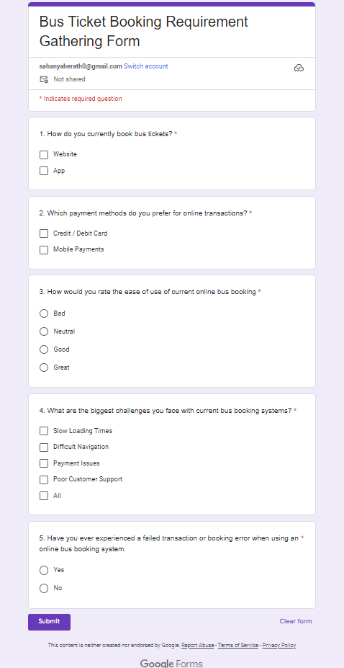

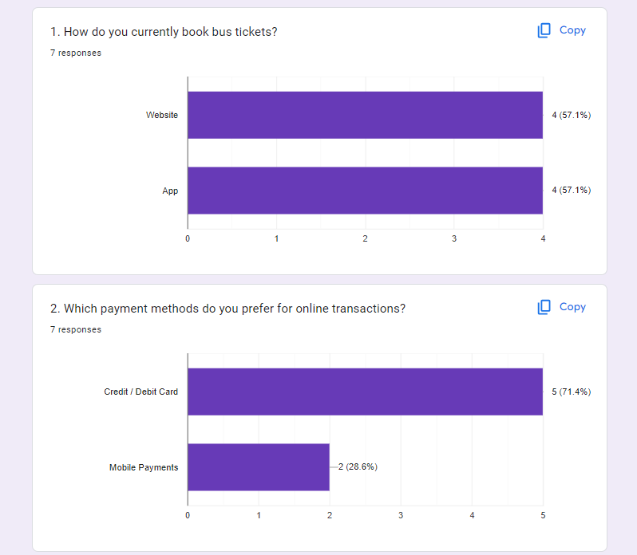Proof

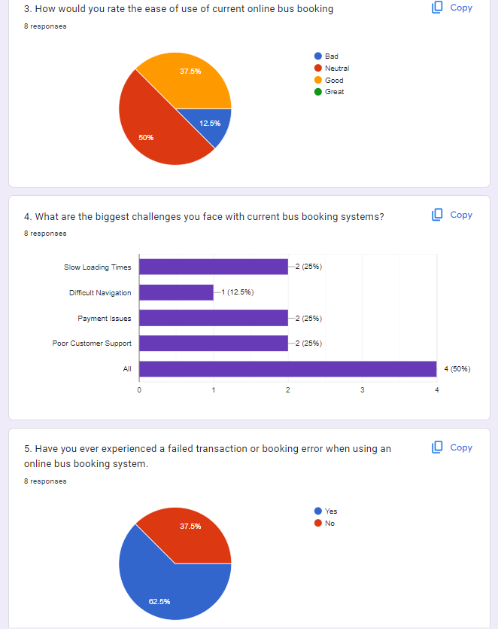

***Observations***

Observational studies were conducted to gain firsthand insights into the real-world challenges and behaviors of bus passengers and operators. This method involved:

* **Observing Current Booking Processes:** The project team observed the manual and digital booking processes at bus stations and online. This included watching how users interact with current systems, noting any difficulties they encounter, and identifying inefficiencies in the process.
* **User Interaction with Existing Platforms:** Observations were made on how users navigate existing bus booking websites and apps, focusing on areas where users struggled or expressed frustration. This helped in understanding the usability issues that TravelEASE needed to address.
* **Operational Challenges:** The team also observed the day-to-day operations of bus companies, focusing on how they manage bookings, schedules, and customer interactions. This provided valuable insights into the administrative needs that TravelEASE would need to fulfill, such as real-time updates on seat availability and efficient schedule management.

The insights gained from these observations were instrumental in identifying key areas for improvement in the TravelEASE platform. By understanding the challenges faced by both users and operators, the project team was able to design a solution that addressed real-world needs and improved the overall efficiency of the booking process.

**Gathered Information from Requirement Gathering (Google Forms & Observations)**

**1. Google Forms**

The survey conducted via Google Forms yielded valuable insights into user expectations, preferences, and common pain points in the current bus booking systems. Here is a summary of the gathered information:

* **Preferred Booking Methods:**
  + A majority of respondents indicated that they currently book tickets in-person or over the phone but would prefer online bookings for convenience.
  + Future preference leaned strongly towards digital platforms for faster, more efficient booking.
* **Payment Preferences:**
  + Most users preferred using credit/debit cards or mobile payments for online transactions.
  + There was also significant interest in integrating modern payment gateways such as PayHere and Stripe to offer diverse payment options.
* **User Interface Preferences:**
  + Users emphasized the need for a simple, intuitive interface. They expressed frustration with cluttered or confusing designs in existing platforms.
  + They preferred a clean layout with easy-to-follow navigation, clear bus options, and an intuitive booking flow.
* **Device Usage:**
  + The survey revealed that the majority of users book tickets through their smartphones, followed by desktops and tablets.
  + This insight highlighted the need for a fully responsive design that works smoothly across mobile devices and desktops.
* **Pain Points in Current Systems:**
  + Slow loading times and confusing booking processes were two of the most common complaints.
  + Users reported difficulty in finding real-time information about seat availability and schedules.
  + Other pain points included poor customer support and issues with online payment systems, often leading to incomplete bookings or errors during the payment process.

**2. Observations**

The observational studies conducted by the project team provided in-depth insights into the operational challenges and user behaviors observed during the current booking processes. Here is the gathered information:

* **Observing Current Booking Processes:**
  + Many users still rely on manual booking methods at bus stations, which are slow and prone to errors, especially during peak travel periods.
  + Common issues included long queues, lack of real-time seat information, and manual errors in bookings.
* **User Interaction with Existing Platforms:**
  + Users interacting with digital booking platforms often struggled with unclear interfaces, poor mobile responsiveness, and a lack of real-time updates.
  + Many users spent a long time navigating through complex steps, leading to frustration and abandonment of the booking process.
* **Operational Challenges:**
  + Bus operators faced challenges in managing schedules, seat availability, and handling customer requests in real-time due to outdated systems.
  + Lack of automated booking systems led to double bookings, especially when dealing with both online and manual reservations.
  + Bus operators struggled to generate reports and track performance metrics efficiently, which affected decision-making and service optimization.

Here’s a summary of how the TravelEASE web application will address the identified issues:

1. **Online Booking Integration:** Implement a user-friendly online booking system to replace in-person and phone bookings.
2. **Diverse Payment Options:** Integrate modern payment gateways (PayHere, Stripe) to support credit/debit cards and mobile payments.
3. **Intuitive Design:** Create a clean, easy-to-navigate interface with a responsive design for seamless use across all devices.
4. **Mobile-First Approach:** Ensure the platform is optimized for mobile devices, reflecting most users' preferences.
5. **Real-Time Updates:** Provide real-time information on seat availability and schedules and optimize loading times.
6. **Improved Customer Support:** Offer efficient customer support options to resolve issues quickly.
7. **Automated Booking Management:** Reduce manual errors and double bookings with automated booking systems.
8. **Efficient Scheduling and Reporting:** Provide tools for better management of bus schedules, seat availability, and performance metrics.

These solutions will enhance user experience, streamline operations, and address the pain points identified in current booking systems.

## Resource Identification

The resources identified for the TravelEASE project include hardware, software, and human resources. Hardware requirements include four high-performance laptops, while software tools like Laravel Herd, VS Code, and browser environments (Chrome, Edge) are essential for development. The project team consists of a Project Manager, Full-Stack Developer, UI/UX Designer, and QA Engineer, each bringing critical skills to the project.

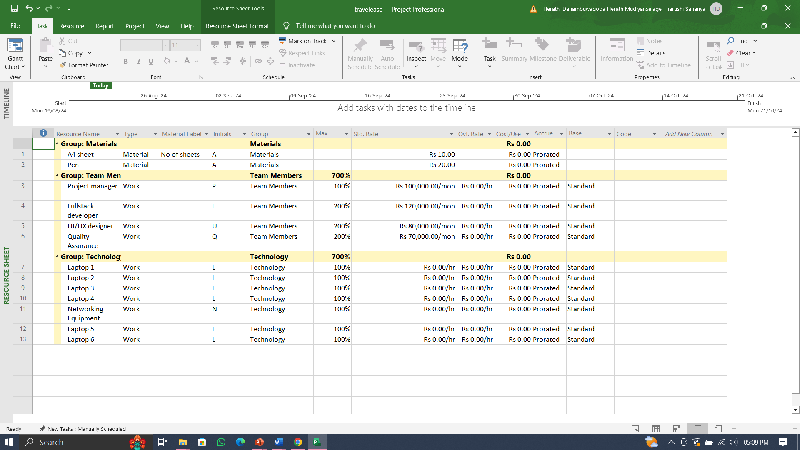

## Work break down structure

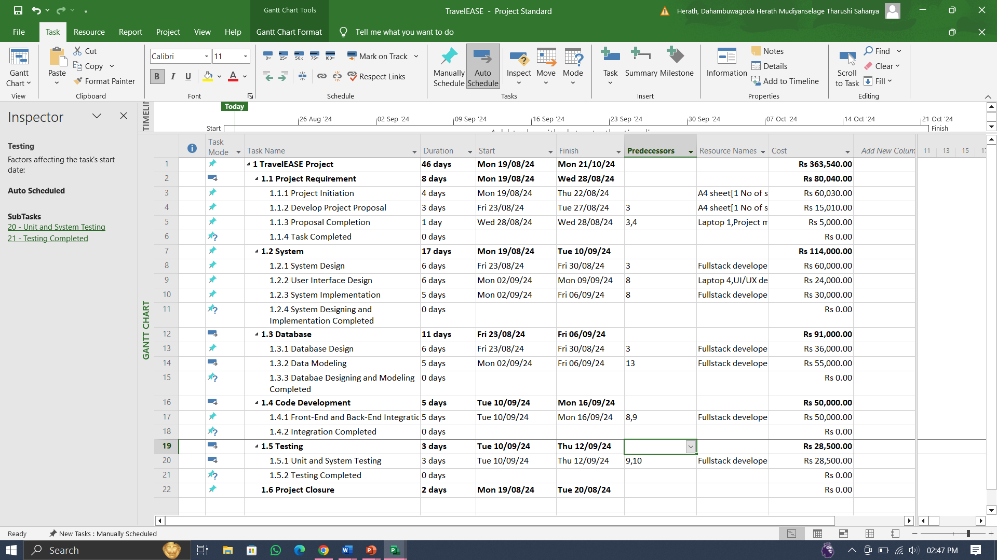

## Risk Analysis

1. **Missed Deadlines:**

Risk of missing deadlines due to unforeseen challenges. Mitigation includes setting internal deadlines ahead of the official timeline and planning to complete the project a week early.

1. **Code Issues and Bugs:**

Potential for bugs disrupting development. Mitigated by implementing a comprehensive testing strategy with continuous testing to identify and resolve issues early.

1. **Failure to Meet User Expectations:**

Risk that the final product may not meet user needs. Addressed by conducting regular user feedback sessions and having alternative design solutions ready for quick adjustments.

1. **Lower Productivity or Team Issues:**

Risk of reduced productivity or team-related problems. Managed by closely monitoring progress, adjusting workloads, and prioritizing key features if necessary.

1. **Third-Party Payment Gateway Outage:**

Potential disruption from payment gateway outages. Mitigated by preparing alternative payment solutions and establishing contingency agreements with multiple providers.

1. **Server Downtime or Performance Issues:**

Risk of server downtime affecting user experience. Addressed by using redundant server architecture, regular backups, and cloud-based auto-scaling for performance during high traffic.

1. **Security Breaches or Data Leaks:**

Risk of security incidents compromising data. Managed through regular security audits, strict encryption, and an emergency response plan for rapid incident resolution.

# Chapter 3

## Design of the system

### Database

**ER Diagram**

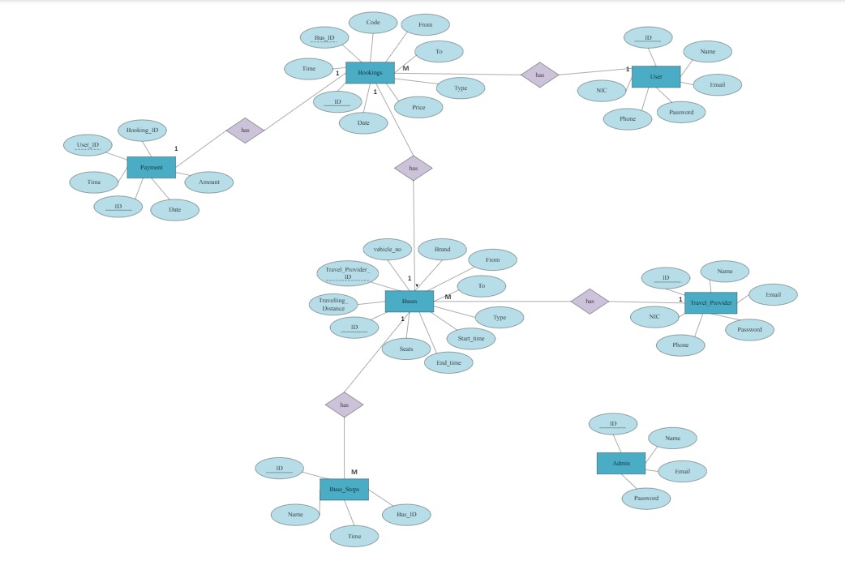

**Entity relationship mapping**

**Step 01 - Strong entity mapping**

User

|  |  |  |  |  |  |
| --- | --- | --- | --- | --- | --- |
| ID | Name | Email | Password | Phone | NIC |

Admin

|  |  |  |  |
| --- | --- | --- | --- |
| ID | Name | Email | Password |

Travel_Provider

|  |  |  |  |  |  |  |
| --- | --- | --- | --- | --- | --- | --- |
| ID | Name | Email | Password | Address | Phone | NIC |

Buses

|  |  |  |  |  |  |  |  |  |  |  |
| --- | --- | --- | --- | --- | --- | --- | --- | --- | --- | --- |
| ID | Vehicle_  No | Travel_Provider_ID | Brand | From | To | Type | Start_Time | End_Time | Seats | Travelling_  Distance |

Bus_Stops

|  |  |  |  |
| --- | --- | --- | --- |
| ID | Bus_ID | Name | Time |

**Step 02 – Weak entity mapping**

Bookings

|  |  |  |  |  |  |  |  |  |  |
| --- | --- | --- | --- | --- | --- | --- | --- | --- | --- |
| ID | Time | Date | Code | From | To | Type | Price | User_ID | Bus_ID |

Payment

|  |  |  |  |  |  |
| --- | --- | --- | --- | --- | --- |
| ID | Time | Date | Amount | User_ID | Booking_ID |

**Conclusion:**

The ERD provided is in 3rd Normal Form (3NF), making it a well-structured and efficient database design. All entities are properly normalized, and relationships are correctly modeled to eliminate redundancy and maintain data integrity.

## System Design

### UML Diagram

**Use Case Diagram**

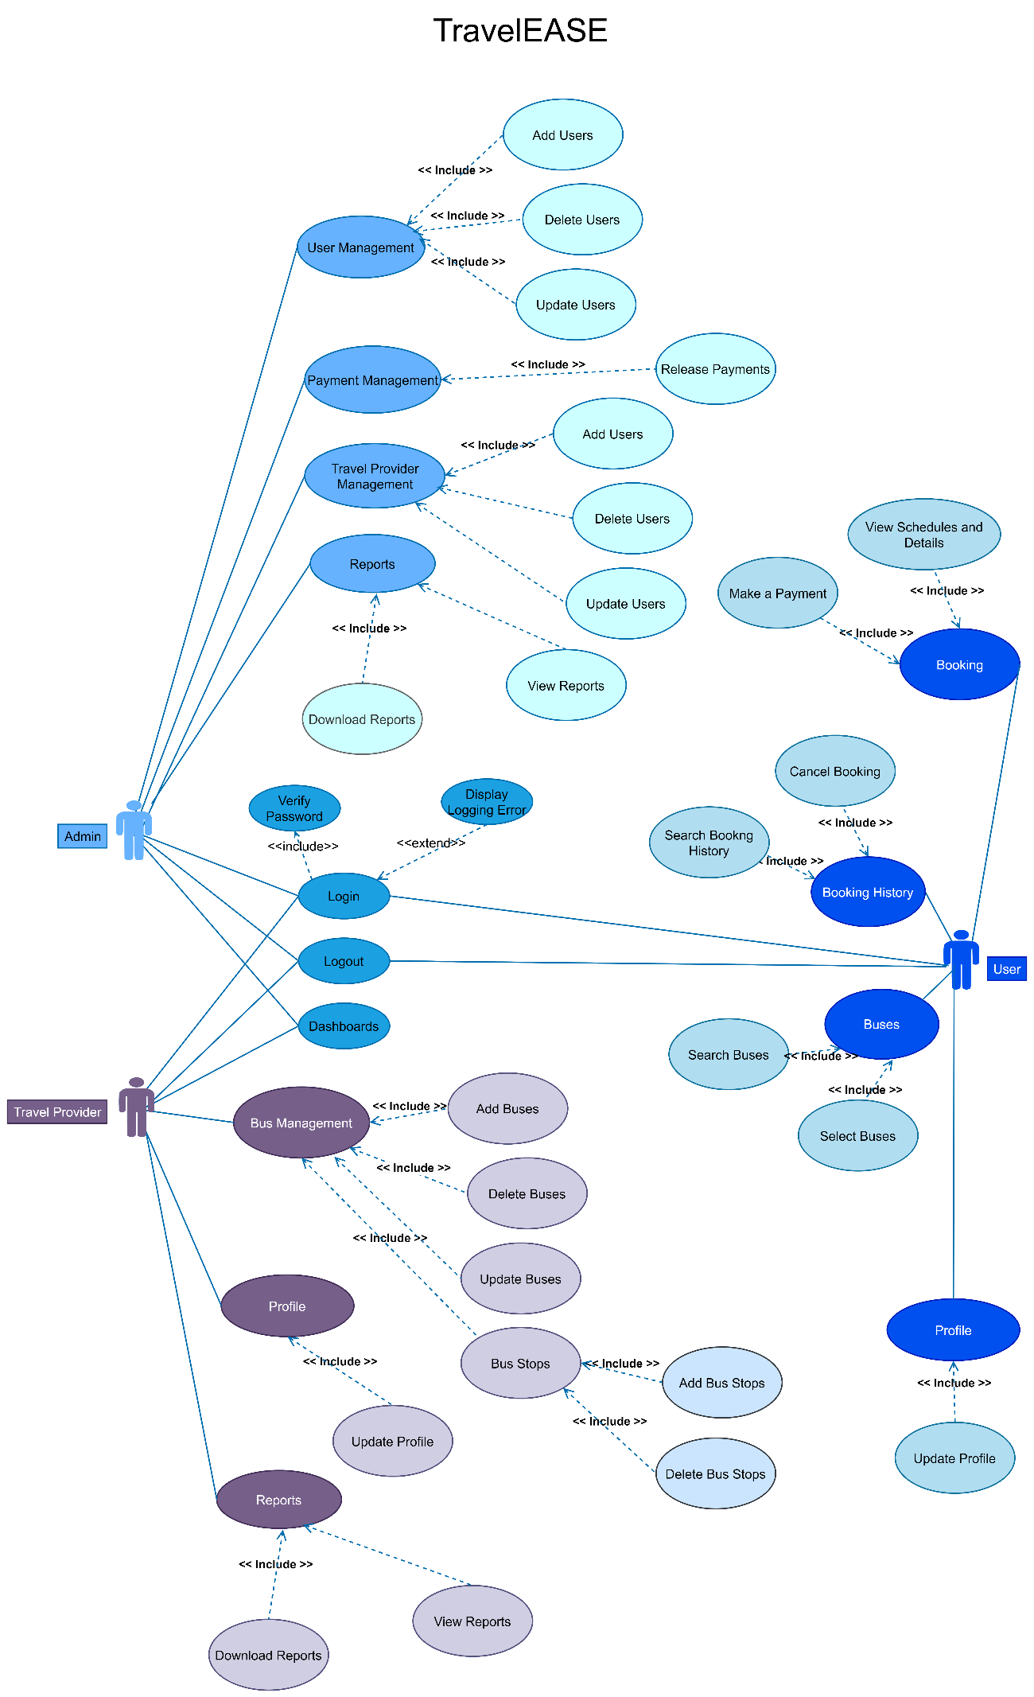

**Class Diagram**

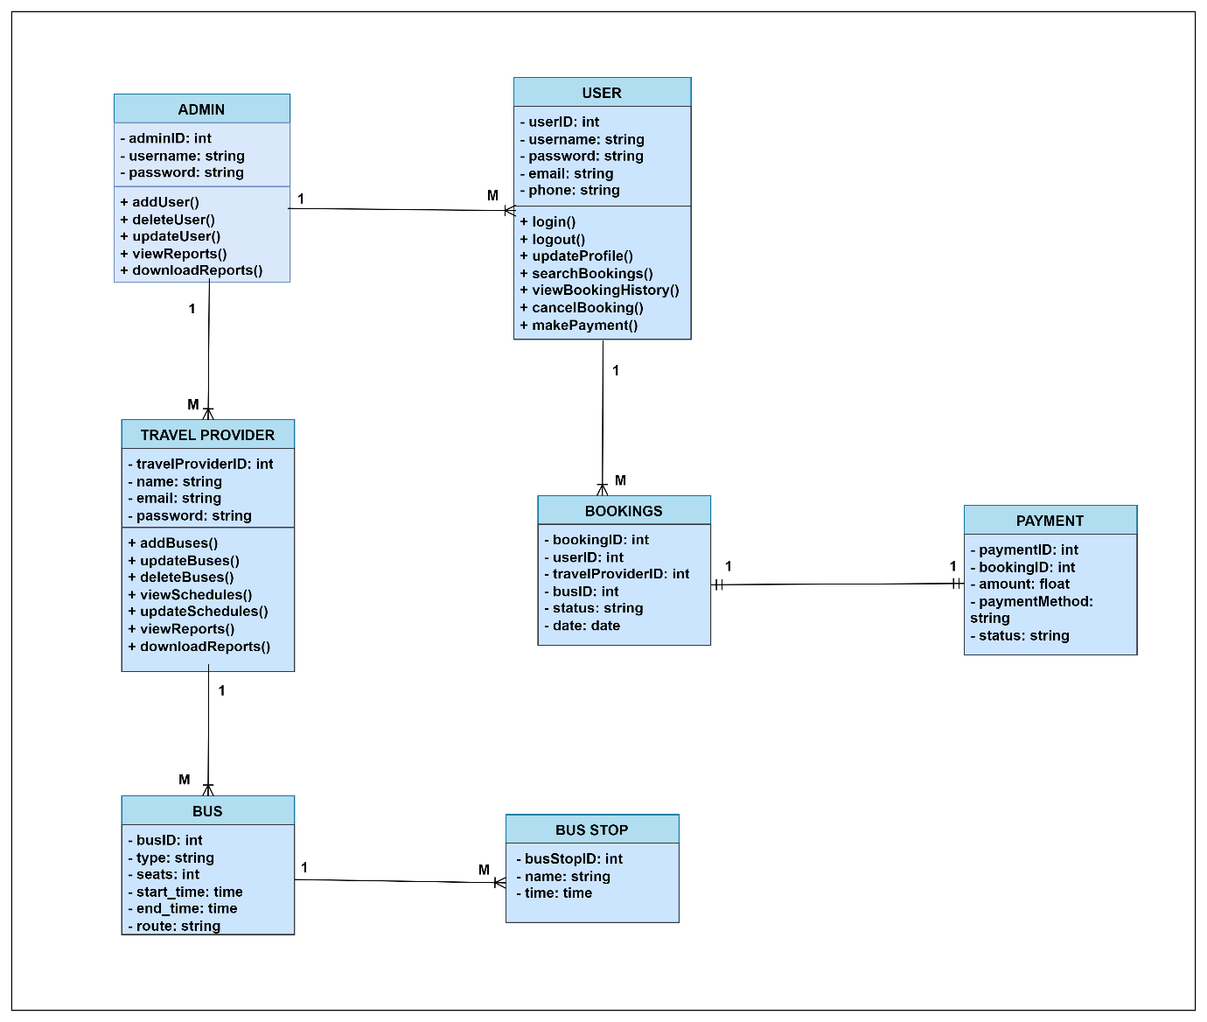

The class diagram outlines the system's structure, showing classes like User, Admin, Travel Provider, Bus, Bookings, Payment, and Bus Stop, with their attributes, methods, and relationships.

**Sequence Diagram**

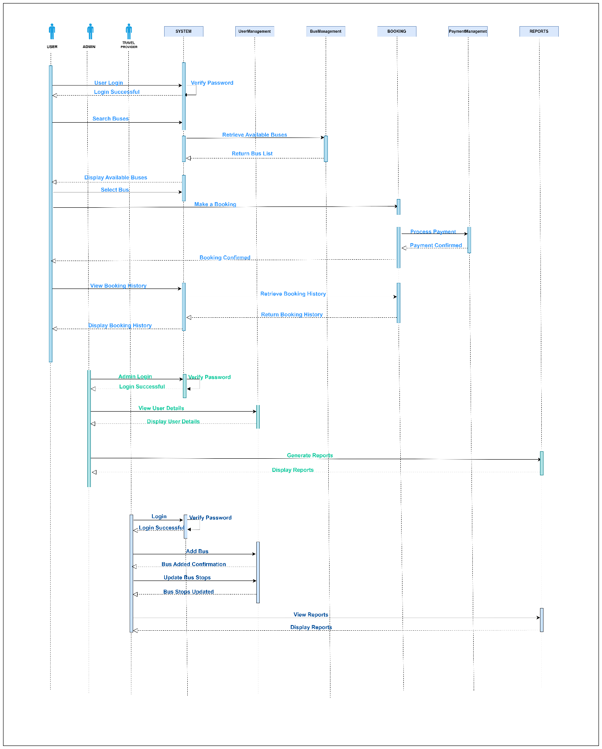

The sequence diagram shows the interactions between users, admins, travel providers, and the system for logging in, searching buses, making bookings, processing payments, managing buses, and generating reports.

## User Interfaces / Navigations

### Wireframes

**Main Menu**

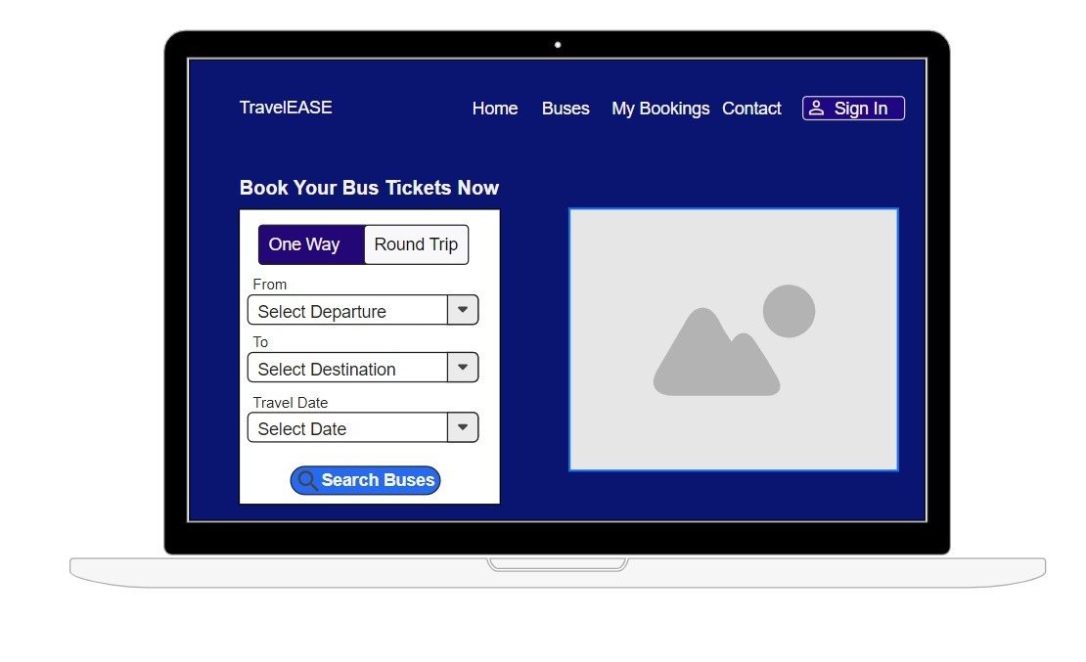

**Find Buses**

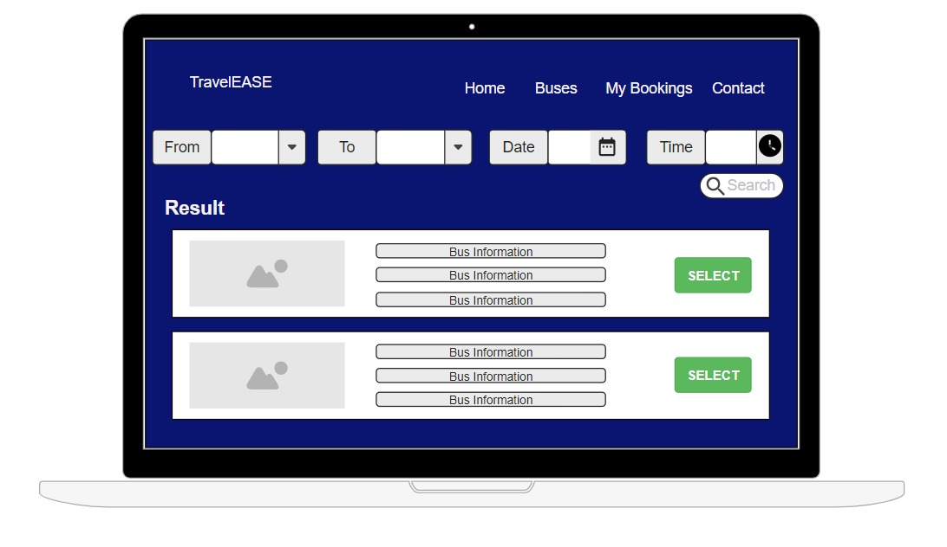

**My Bookings**

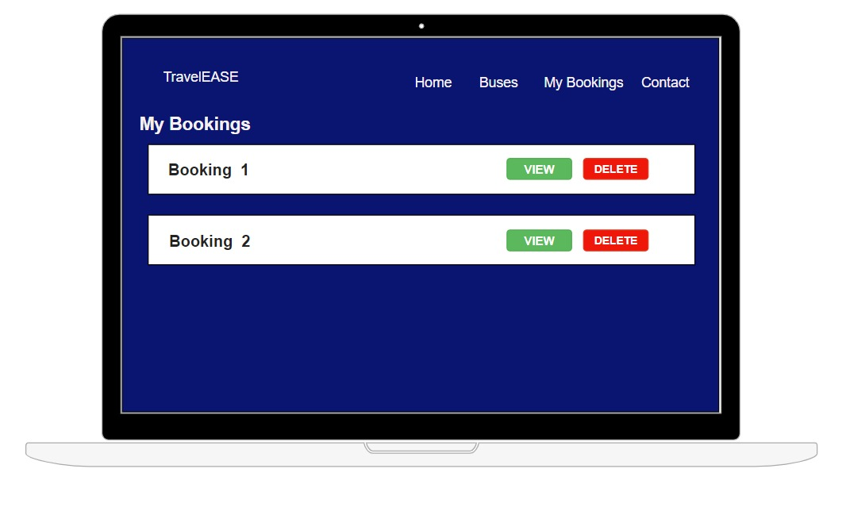

**Contact Us**

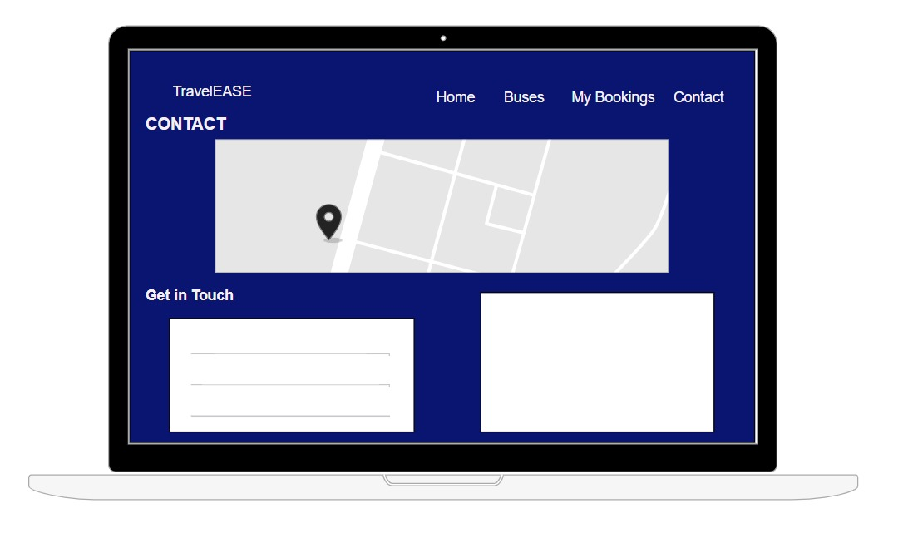

**Sign In**

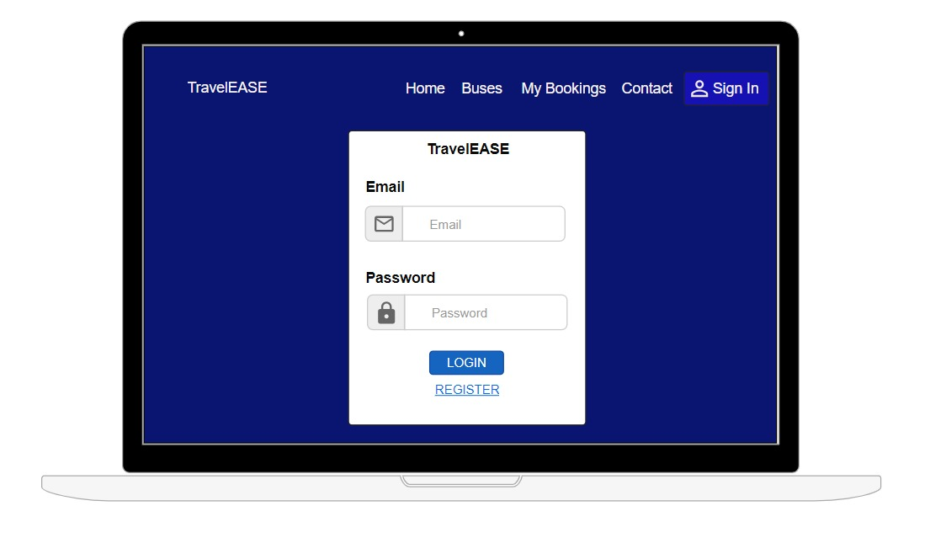

**Sign Up**

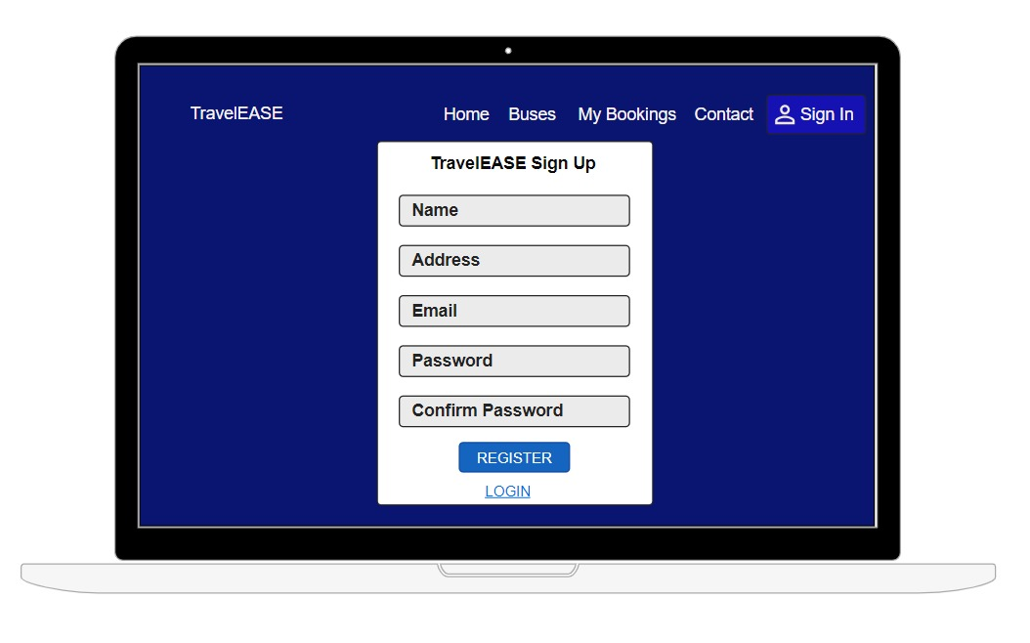

**Admin Dashboard**

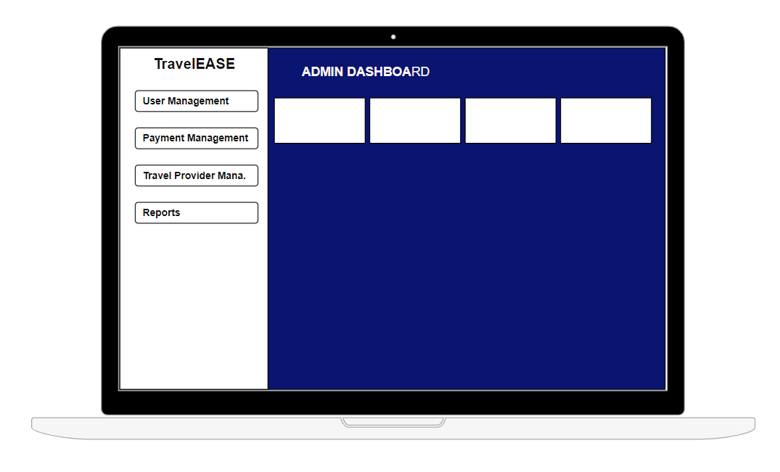

**Travel Provider Dashboard**

**Other Sections**

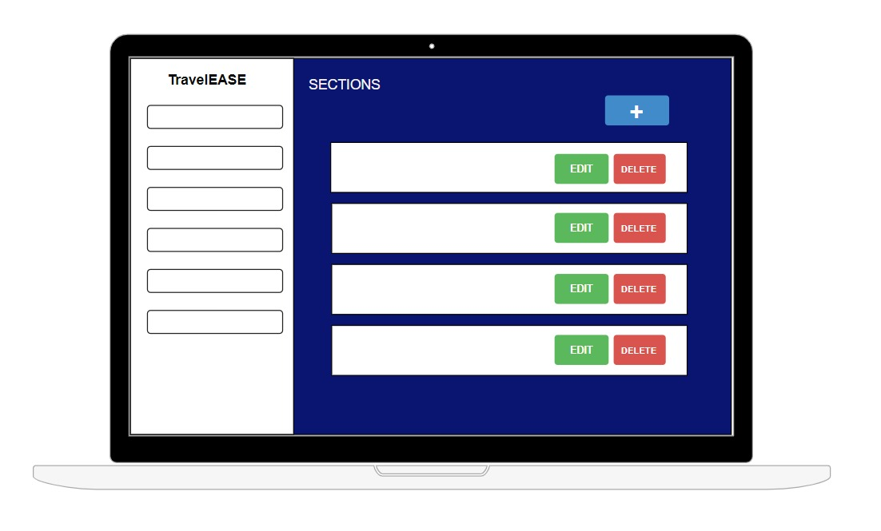

**Add Model Design in all Sections**

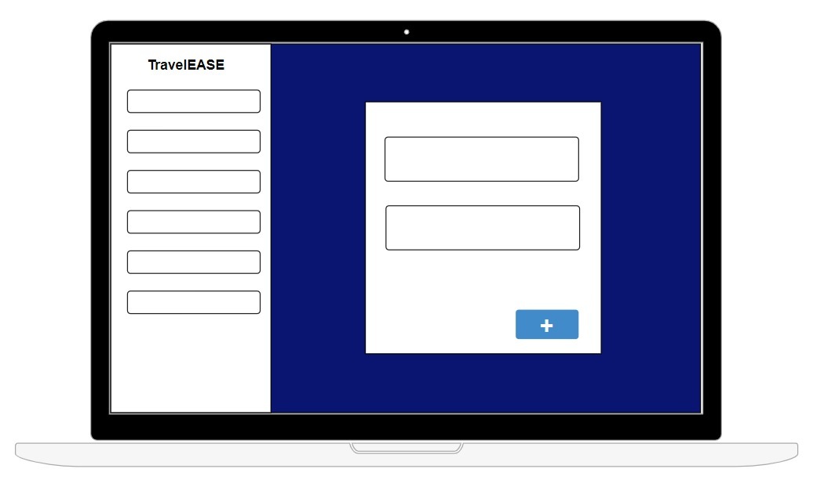

# References

Anon., n.d. *busseat.* [Online]   
Available at: https://busseat.lk/  
[Accessed 17 August 2024].

Anon., n.d. *flixbus.* [Online]   
Available at: https://global.flixbus.com/  
[Accessed 19 August 2024].

Anon., n.d. *redbus.* [Online]   
Available at: https://www.redbus.in/travels/international-tourist-center  
[Accessed 18 August 2024].

Anon., n.d. *sltb.eseat.* [Online]   
Available at: https://sltb.eseat.lk/  
[Accessed 17 August 2024].

geeksforgeeks, 2024. *geeksforgeeks.* [Online]   
Available at: https://www.geeksforgeeks.org/what-is-agile-methodology/  
[Accessed 19 August 2024].